Practical 4A: Write a program to demonstrate attributes of table tag, display columns with different colors, consider dummy values

<html>

<body>

<table border=1 width="20px" align="center" cellspacing="20px" cellpdding="10px" background="pic.jpg">

<tr>

<th valign="10px" bgcolor="red">Name</th>

<th bgcolor="yellow">RollNo</th>

<th bgcolor="#b3f542">Contact</th>

<th bgcolor="green">Location</th>

<th bgcolor="#d795f5">Course</th>

</tr>

<tr>

<td bgcolor="red">Shreya</td>

<td bgcolor="yellow">019</td>

<td bgcolor="#b3f542">9098943244</td>

<td bgcolor="green">Mumbai</td>

<td bgcolor="#d795f5">BscIT</td>

</tr>

<tr>

<td bgcolor="red">Rachel</td>

<td bgcolor="yellow">016</td>

<td bgcolor="#b3f542">387492422</td>

<td bgcolor="green">Mumbai</td>

<td bgcolor="#d795f5">Bmm</td>

</tr>

<tr>

<td bgcolor="red">Sheetal</td>

<td bgcolor="yellow">027</td>

<td bgcolor="#b3f542">7985943212</td>

<td bgcolor="green">Pune</td>

<td bgcolor="#d795f5">b=BscCS</td>

</tr>

<tr>

<td bgcolor="red">Shaizeen</td>

<td bgcolor="yellow">027</td>

<td bgcolor="#b3f542">798394121</td>

<td bgcolor="green">Delhi</td>

<td bgcolor="#d795f5">BscIT</td>

</tr>

</table>

</body>

</html>

Output:

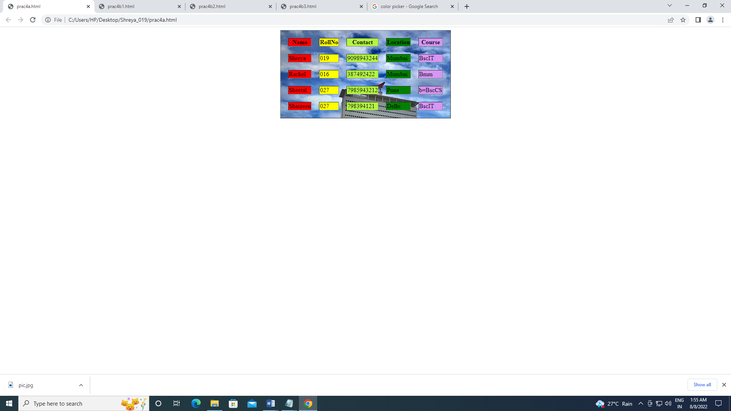

4b:Write html code to get following ouput:

<html>

<body>

<table border=1>

<tr>

<th colspan="3">TyBscIT</th>

</tr>

<tr>

<td colspan="2">Main</th>

<td>AC</td>

</tr>

<tr>

<td>DCN</td>

<td rowspan="2">Linux</th>

<td rowspan="2">WebP</th>

</tr>

<tr>

<td>Data Comm</td>

</tr>

<tr>

<td rowspan="2">Java</td>

<td>OOP</th>

<td rowspan="2">WebD</th>

</tr>

<tr>

<td>OOD</td>

</tr>

</table>

</body>

</html>



4b.2.

<html>

<body>

<table border=1, cellspacing="20px">

<tr>

<th colspan="4">1</th>

</tr>

<tr>

<td colspan="2">2</td>

<td colspan="2">3</td>

</tr>

<tr>

<td>4</td>

<td>5</td>

<td>6</td>

<td>7</td>

</tr>

<tr>

<td colspan="4", align="center">8 & 9</td>

</tr>

</table>

</body>

</html>



4.b.3.

<html>

<body>

<table border=1>

<tr>

<th colspan="3" bgcolor="#b3f542">A</th>

</tr>

<tr>

<td rowspan="2" bgcolor="yellow">B</td>

<td bgcolor="red">C</td>

<td rowspan="2" bgcolor="green">E</td>

</tr>

<tr>

<td bgcolor="#d795f5">D</td>

</tr>

<tr>

<th colspan="3" bgcolor="#bea9f5">F</th>

</tr>

<tr>

<th colspan="2" bgcolor="#ff57fc">G</th>

<th colspan="2" bgcolor="#ff57fc">H</th>

</tr>

</table>

</body>

</html>

